**HANOI UNIVERSITY OF SCIENCE AND TECHNOLOGY**



**Project I**

**ADAPTIVE SLIDING MODE CONTROL**

**OF A PEM FUEL CELL SYSTEM**

**BASED ON THE SUPER TWISTING ALGORITHM**

**ĐỖ QUANG THÀNH -** [Thanh.dq202770@sis.hust.edu.vn](mailto:Thanh.dq202770@sis.hust.edu.vn)

**NGUYỄN TUẤN DƯƠNG -** [Duong.nt202740@sis.hust.edu.vn](mailto:Duong.nt202740@sis.hust.edu.vn)

**NGUYỄN ĐÌNH TOÀN -** [Toan.nd202775@sis.hust.edu.vn](mailto:Toan.nd202775@sis.hust.edu.vn)

**VÕ KHÔI THÀNH SƠN –** [Son.vkt202768@sis.hust.edu.vn](mailto:Son.vkt202768@sis.hust.edu.vn)

**Control Engineering and Automation**

|  |  |
| --- | --- |
| **Instructing teacher:** | Dr. Vu Thi Thuy Nga |
| **Department:** | Automation |
| **University:** | Hanoi University of Science and Technology |

**HÀ NỘI, 8/2023**

**Acknowledgement**

Through this course and research, we have had the chance to learn the basics of a control system. In addition, we are able to cooperate with friends to work on a new and interesting topic which can contribute greatly to society in the future. With this, we want to express our gratitude towards my instructor, Mrs Vu Thi Thuy Nga, as well as our seniors for helping us along the course.

**Abstract**

Proton exchange membrane fuel cells (PEMFCs) are the most promising fuel cell technology because of their high-power density, low operating temperature, quick startup capability, and low weight. Efficient use of the PEMFC requires keeping it working at an adequate power point and protecting fuel cells from damage problems. Through this course, we learn how to extract the maximum power from the PEMFC system and protect it from membrane damage by stabilizing the hydrogen and oxygen partial pressure. To this end, a control scheme composed of a maximum power point tracking (MPPT) controller and pressure controller is proposed. The second order sliding mode control (SMC) is used to overcome the chattering phenomenon caused by the conventional SMC.

**CONTENTS**

**I.** **Introduction** 7

**II.** **PEM fuel cell system modeling** 8

2.1. PEM fuel cell 8

2.2. System modeling 9

**III.** **Control design of the PEM fuel cell system** 12

3.1. Sliding mode control approach 12

3.2. Adaptive sliding mode control based on super-twisting algorithm 13

**IV.** **Experiment and results** 14

4.1. Simulation model in MATLAB: 14

a) Fuel cell: 14

b) MPPT controller: 15

c) Dynamic circuit: 15

4.2. Results: 16

a) Power: 16

b) Boost converter output current: 17

c) Boost converter output voltage: 18

d) Fuel cell current 19

e) Fuel cell voltage: 20

f) Control signal: 20

**V.** **Conclusion** 21

**REFERENCE** 22

**FIGURE LIST**

Figure 1. The proposed system configuration 9

Figure 2. Fuel cell modeling 11

Figure 3. Fuel cell characteristics for various values of temperature and membrane water content 11

Figure 4. Control scheme of the PEM fuel cell power system 12

Figure 5. Simulation model for fuel cell system 14

Figure 6. Fuel cell model 14

Figure 7. Boost converter circuit 15

Figure 8. Power of PEM fuel cell 16

Figure 9. Boost converter output curent 17

Figure 10. Boost converter output voltage 18

Figure 11. Fuel cell current 19

Figure 12. Fuel cell voltage 20

Figure 13. Duty cycle signal 20

**TABLE LIST**

Table 1. Specification details of the PEM fuel cell system 10

1. **Introduction**

Fuel cells are one of the environmentally friendly energy sources that generate electricity through an electrochemical reaction. At the moment, there are six main fuel cell types classified according to the electrolyte and fuel used: phosphoric acid fuel cell (PAFC), molten carbonate fuel cell (MCFC), alkaline fuel cell (AFC), solid oxide fuel cell (SOFC), proton exchange membrane fuel cell (PEMFC), and direct methanol fuel cell (DMFC). Among the mentioned types of fuel cell, PEMFC stands out to be the most popular type for mobile and portable applications, due to some advantages such as: heat and water management, a high power density, the reaction of electrode kinetics, alternative catalysts, a low weight, and a low operating temperature. However, PEMFC presents some disadvantages: very high sensitivity to impurities of hydrogen, expensive catalyst and membrane, a gas diffusion layer and flow field layers, degradation, and production difficulties of the membrane electrode assembly.

PEMFC consists of a polymer electrolyte membrane placed in the middle of two electrodes called anode and cathode. Hydrogen fuel is fed through the anode and an oxidant (air or pure oxygen) is pumped into the cathode. Hydrogen molecules are split into electrons and hydrogen protons at the anode catalyst. Hydrogen protons migrate toward the cathode through the membrane and react with the returning electrons and oxygen to produce water and heat. Free electrons at the anode will flow to the cathode through an external load and provide electricity.

PEMFC system control has to take into account problems related to harvesting electrical energy from the PEMFC stack. Fuel cells have a nonlinear voltage–current characteristic, and the power has several local maximum power points in the I–P characteristic under various operating conditions. Therefore, an MPPT algorithm must be established to improve and optimize the PEMFC system efficiency. The problem of fuel starvation as a result of sudden load variations can lead to serious membrane damage in the fuel cell. This problem can be avoided by controlling the inlet flow rates of hydrogen and oxygen to stabilize the partial pressures and protect the fuel cell from damage.

To achieve this aim, a robust control scheme based on the second order sliding mode control is elaborated. The control scheme is composed of an MPPT controller and pressure controller. The pressure control was set using the super twisting algorithm, while the MPPT control was carried out using an adaptive sliding mode controller. The effectiveness and the superiority of the ASMC in terms of convergence time and power extraction is proved through a comparison study with conventional SMC and STA.

In this research, however, we are considering the source tank in ideal condition, with the pressure at a constant level.

1. **PEM fuel cell system modeling**
   1. PEM fuel cell

The FC output voltage can be described as follows:

$V_{cell}=E_{Nernst}-{η }_{act}-{η }_{ohmic}-{η }_{con}$

(1)

$E_{Nernst}$ is the reversible open-circuit voltage, it is described by the Nernst equation as:

$$E_{Nernst}=1.229-8.5×{10}^{-4}\left(T-298.15\right)+4.308×{10}^{-5}\left(lnP_{O_{2}}+lnP_{H_{2}}\right)$$

(2)

where $P_{H_{2}}$ is the hydrogen partial pressure (atm), $P_{O_{2}}$ is the is oxygen partial pressure (atm) and *T* is the absolute temperature (K).

${η }_{act}$ is the activation voltage drop, it is given in the Tafel equation as:

${η }_{act}={ξ }_{1}+{ξ }_{2}T+{ξ }_{3}T{lnC}_{O_{2}}+{ξ }_{4}T{lnI}_{FC}$

(3)

where $I_{FC}$ is the fuel cell current (A), and ${ξ }_{i}$ (i=1-4) are parametric coefficients for each cell model. $C_{O_{2}}$ represents the concentration of dissolved oxygen in the interface of the cathode catalyst which can be calculated as:

$$C_{O_{2}}=\frac{P_{O_{2}}}{(5.08×{10}^{6})e^{\frac{-498}{T}}}$$

(4)

${η }_{ohmic}$ is the overall ohmic voltage drop, it can be expressed as:

$${η }_{ohmic}=I_{FC}R_{m}$$

(5)

where $R_{m}$ is the ohmic resistance and given by:

$$R_{m}=\frac{r_{m}t_{m}}{A}$$

(6)

where Ais the cell active area (cm2), *tm* is the membrane thickness (cm). $r_{m}$ is the membrane resistivity (Ωcm) to proton conductivity and can be calculated as:

$$r_{m}=\frac{181.6[1+0.03\left(\frac{I_{FC}}{A}\right)+{0.0062(T/303)}^{2}{(\frac{I_{FC}}{A})}^{2.5}]}{[{λ }_{m}-0.634-3(\frac{I_{FC}}{A})]e^{4.18(T-303/T)}}$$

(7)

where ${λ }_{m}$ represent the membrane water content and it is a function of the average water activity $a_{m}:$

${λ }_{m}=\left\{\begin{aligned}0.043+17.81a_{m}-39.85{a_{m}}^{2}+36{a_{m}}^{3} if 0<a_{m}<1 \\ 14+14\left(a_{m}-1\right) if 1<a_{m}<3\end{aligned}\right.$

(8)

The average water activity is function of the cathode water vapor partial pressure $P_{v,ca}$,the anode water vapor partial pressure $P_{v,an}$ and the saturation pressure of water $P_{sat}$. It can be expressed as:

$$a_{m}=\frac{1}{2}\left(a_{an}+a_{ca}\right)=\frac{1}{2}\frac{P_{v,an}+P_{v,ca}}{P_{sat}}$$

(9)

$P_{sat}$ can be obtained using the following empirical expression:

$\log_{10}P_{sat}$ = −2.1794 + 0.02953T − 9.1813 × ${10}^{-5}T^{2}$ + 1.4454 × ${10}^{-7}T^{3}$

(10)

${η }_{con}$ is the concentration voltage drop, it is expressed as:

$${η }_{con}=-\frac{RT}{nF}ln⁡(1-\frac{I_{FC}}{i_{L}A})$$

(11)

where *F* is the Faraday’s constant, *n* is the number of electrons participating in the reaction, $i_{L}$ is the limiting current and *R* is the universal gas constant.

The output voltage of a fuel cell stack constitutes by $N_{FC}$ fuel cells connected in series is given by:

(12)

* 1. System modeling

The PEM fuel cell system adopted in this study is shown in *Fig. 1*.

Figure 1. The proposed system configuration

It is constituted by an FC stack, a DC/DC boost converter, and a resistive load. The boost converter is used to increase the system’s efficiency by controlling the fuel cell system’s operation point through adjusting the duty cycle of the converter. The specification details of the PEM fuel cell system is given in *Table 1*.

Table 1. Specification details of the PEM fuel cell system

|  |  |
| --- | --- |
| Parameter | Value |
| $$N_{FC}$$ | 24 |
| A | 232 ${cm}^{2}$ |
| $${ξ }_{1}$$ | 0.944 |
| $${ξ }_{2}$$ | -0.00354 |
| $${ξ }_{3}$$ | -7.8× ${10}^{-8}$ |
| $${ξ }_{4}$$ | 1.96× ${10}^{-4}$ |
| n | 2 |
| $$i_{L}$$ | 2 ${Acm}^{2}$ |
| T | 335 K |
| C | 7000× ${10}^{-6}$ F |
| L | 29× ${10}^{-3}$ H |
| R | 8314.47 j ${(kmol K)}^{-1}$ |
| F | 96484600 ${Ckmol}^{-1}$ |

The dynamic equation of the system can be expressed as follows:

$$\left\{\begin{aligned}{\dot{I}}_{L}=\frac{V_{O}}{L}\left(u-1\right)+\frac{V_{st}}{L} \\ {\dot{V}}_{O}=\frac{I_{L}}{C}\left(1-u\right)-\frac{V_{O}}{RC}\end{aligned}\right.$$

(13)

where $I_{L}$ and $V_{o}$ are the inductor current and the voltage at the output terminals of the boost converter, *u* is the duty ratio. It is assumed that $I_{L}$ is equal to $I_{FC}$.

Eq. (13) can be written as:

$$\dot{x}=F\left(x,t\right)+G(x,t)u(t)$$

(14)

$$where\left\{\begin{aligned}x={[I_{L} V_{o}]}^{T} \\ F\left(x,t\right)={[\frac{{V_{st}-V}_{o}}{L} \frac{I_{L}}{C}-\frac{V_{O}}{RC}]}^{T}={[F_{1} F_{2}]}^{T} \\ G\left(x,t\right)={[\frac{V_{O}}{L} -\frac{I_{L}}{C}]}^{T}={[G_{1} G_{2}]}^{T}\end{aligned}\right.$$

(15)

The fuel cell output power depends on the load and the operating conditions like air pressure, oxygen partial pressure, cell temperature, and membrane water content. Using MATLAB simulation with various values of temperature and membrane water content (Resistive load, oxygen partial pressure, and hydrogen partial pressure are regulated respectively to 50 Ω, 2 atm, and 2 atm.), we obtain the power-current characteristics of the fuel cell system in fig. 3:

Figure 2. Fuel cell modeling

Figure 3. Fuel cell characteristics for various values of temperature and membrane water content

These curves show the nonlinear characteristic of the fuel cell system, and the power has several local maximum power points (MPP) in the P–I characteristic under variation of cell temperature and membrane water content. Thereby MPP tracking should be used to track its changes.

1. **Control design of the PEM fuel cell system**
   1. Sliding mode control approach

Sliding mode control is a nonlinear control method characterized by a suite of feedback control laws and a high frequency switching control action. It forces the system trajectories to reach a given manifold called sliding surface and remains on it after that. When the system state is maintained on this surface, the system is in sliding mode. Its dynamic is then insensitive to system parameter variations and external disturbances as long as the sliding mode conditions are assured.

The design of the control requires mainly three steps:

* Choosing the sliding surface.
* Guarantying the reaching conditions. It is given by the following inequality:

s(x) $\dot{s}(x)$ < 0

* Designing the control law.

Figure 4. Control scheme of the PEM fuel cell power system

In the proposed control law, the switching control leads to high-frequency oscillations on the system outputs known as the chattering phenomenon, degrading the sliding mode control performance. Several approaches have been considered in the literature to reduce or avoid chattering phenomenon, among them:

* Replacement of the discontinuous control by a saturation action. The control law became:

(16)

(17)

* 1. Adaptive sliding mode control based on super-twisting algorithm

The aim of the adaptive sliding mode control is to design a suitable control law for the fuel cell stack system under external disturbances and model uncertainties. The control law is a combination between an equivalent control and switching control. The equivalent control forces the system to reach the sliding surface. It has been designed previously in sub-section a. The switching control forces the system’s dynamics onto the sliding surface, weakens the chattering, and achieves robustness to external disturbances and model uncertainties. It is designed based on the super twisting algorithm.

This control law combines the advantages of the STA with the conventional SMC. The following equation gives it:

$$u\left(t\right)=u_{eq}+u_{sw}$$

(18)

where $\left\{\begin{aligned}u_{eq}=\frac{V_{O}-V_{st}}{V_{O}} \\ u_{sw}=-k_{1}{\left|s\right|}^{0.5}sgn\left(s\right)-\int{k_{2}sgn\left(s\right)dt}\end{aligned}\right.$

(19)

# **Experiment and results**

# Ảnh có chứa biểu đồ, Kế hoạch, Bản vẽ kỹ thuật, sơ đồ Mô tả được tạo tự độngSimulation model in MATLAB:

Figure 5. Simulation model for fuel cell system

# Fuel cell:

Figure 6. Fuel cell model

|  |  |
| --- | --- |
| Mathematical  Simulation code of  fuel cell | function Vst = circuit(T,lambda,x1,PH2,PO2)  N = 24;  A = 232;  m1 = 0.944;  m2 = -0.00354;  m3 = -7.8*10^-8;  m4 = 1.96*10^-4;  n = 2;  iL = 2;  R = 83144.7;  F = 96484600;  CO2 = PO2/((5.08*10^6)*exp(-498/T));  rm=(181.6*(1+0.03*(x1/A)+0.062*((T/303)^2)*(x1/A)^2.5))  /((lambda-0.634-3*x1/A)*exp(4.18*(T-303/T)));  tm = 175*10^-4;  Rm = rm*tm/A;  E=1.229-8.5*(10^-4)*(T-298.15)+4.308*(10^5)*T*(log(PH2) +log(PO2));  Vact = m1+m2*T+m3*T*log(CO2)+m4*T*log(x1);  Vohmic = x1*Rm;  Vcon = (-R*T/(n*F))*log(1-x1/(iL*A));  Vcell = E - Vact - Vohmic - Vcon;  Vst = N*Vcell; |

# MPPT controller:

|  |  |
| --- | --- |
| Mathematical  MPPT  controller | function [u,s] = MPPT_control(x1, x2, Vst, int1, dx1,dVst)  k1 = 2;  s = Vst + x1*(dVst/dx1);  u = (x2-Vst)/x2 + k1*(abs(s))^0.5 *sign(s) + int1; |

Figure 7. Boost converter circuit

|  |  |
| --- | --- |
| Mathematical  Dynamic  Circuit | function [x1_d, x2_d] = circuit(u,x1,x2,Vst)  C = 7000*10^-6;  L = 29*10^-3;  R1 = 50;  x1_d = (Vst-x2)/L + (x2/L)*u;  x2_d = x1/C - x2/(R1*C) - (x1/C)*u; |

# Results:

# Power:

Time(s)

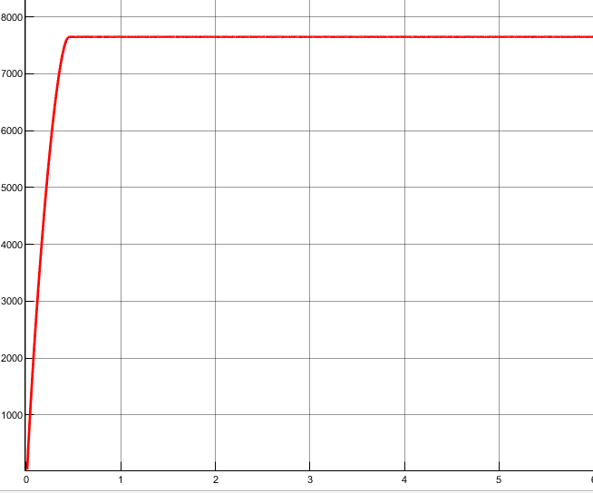

Power(W)

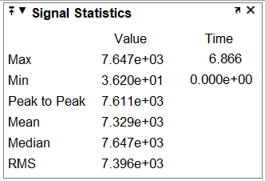

Figure 8. Power of PEM fuel cell

# Boost converter output current:

Figure 9. Boost converter output curent

Time(s)

Current(A)

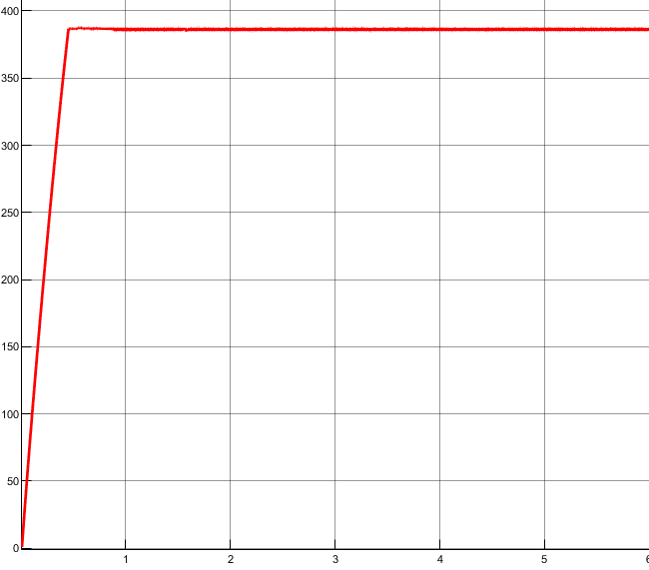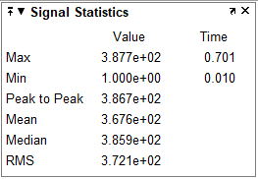

# Boost converter output voltage:

Figure 10. Boost converter output voltage

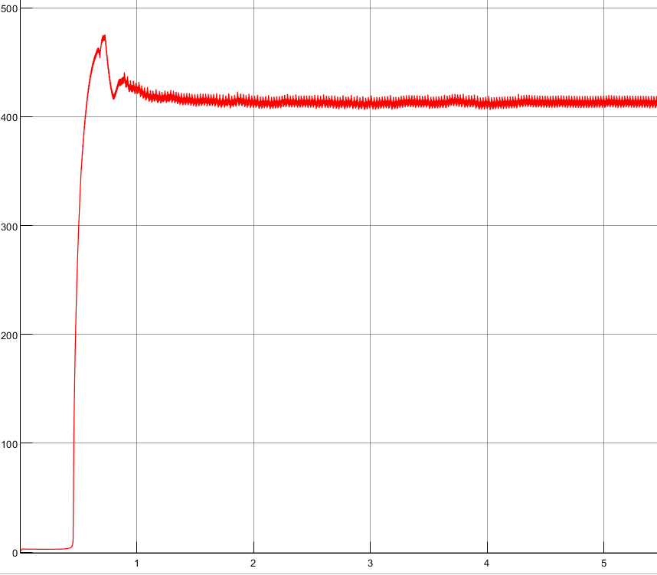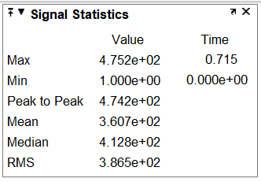

Voltage(V)

Time(s)

# Fuel cell current

Figure 11. Fuel cell current

Time(s)

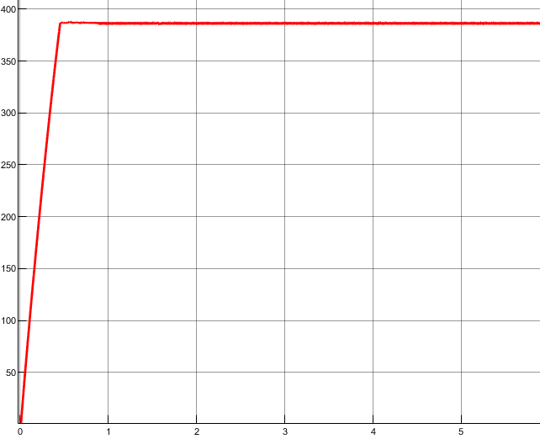

Current(A)

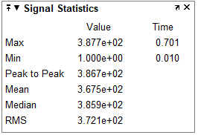

# Fuel cell voltage:

Figure 12. Fuel cell voltage

Time(s)

Voltage(V)

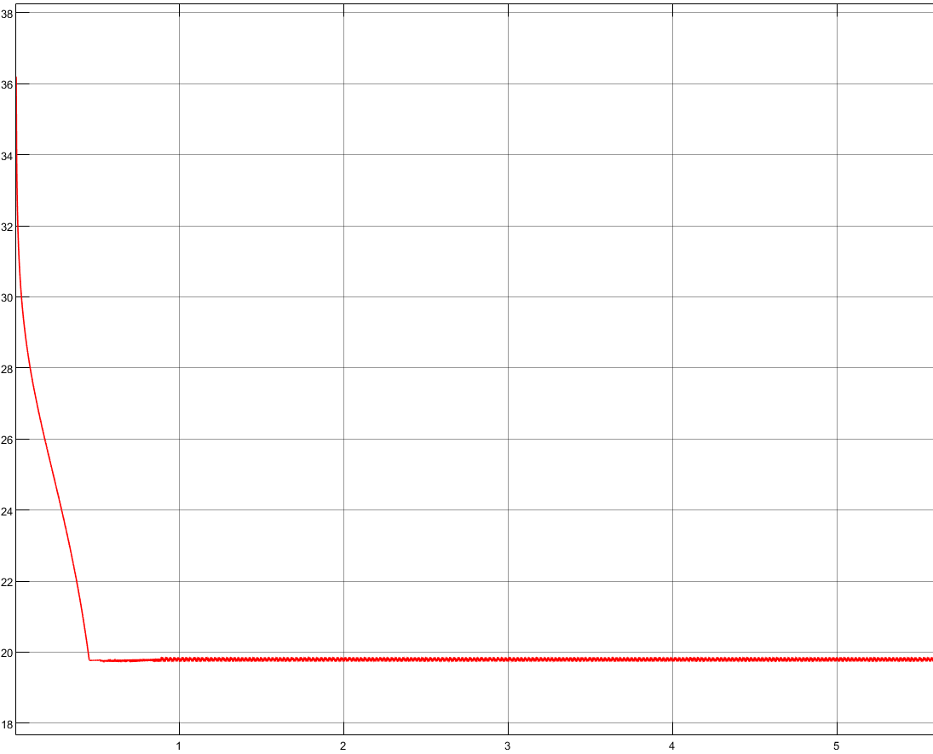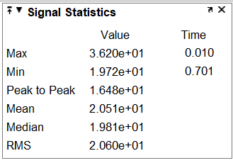

# Control signal:

Figure 13. Duty cycle signal

Time(s)

Voltage(V)

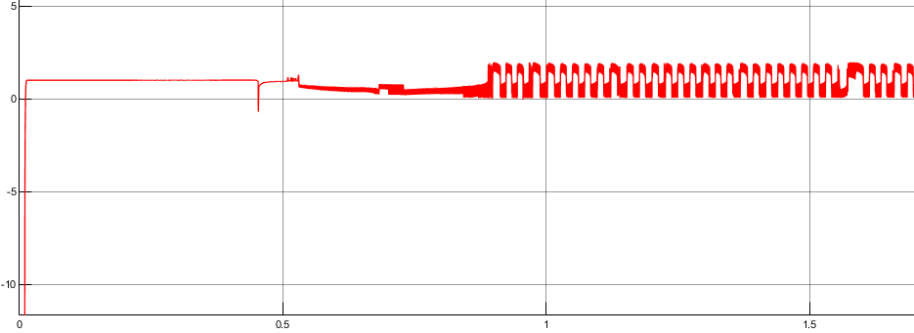

1. **Conclusion**

Following our comprehensive research efforts, we have achieved milestones in the development of a fuel cell model capable of accurately simulating its performance across a wide range of temperatures and membrane water content levels. In this paper, a sliding mode controller for PEMFC system has been designed, successfully extracting the maximum power of the fuel cell. This model serves as a valuable tool in gaining a deep understanding of the intricate interplay between various parameters and the fuel cell's behavior. Additionally, our team has made significant strides in implementing a system within MATLAB Simulink. While this represents a remarkable accomplishment, we acknowledge that there is still room for improvement to fine-tune its operation for optimal performance.

Moving forward, our focus will be on refining and optimizing the adaptive sliding mode control mechanism, ensuring it can adapt seamlessly to dynamic changes in operating conditions, thereby enhancing the fuel cell's stability and efficiency. Furthermore, to align the simulation results with real-life scenarios, we aim to integrate a pressure control mechanism into the fuel cell system. By accounting for the influence of pressure on the cell's performance, we can obtain more accurate and reliable simulations, enabling us to make informed decisions during the design and operational stages.

Moreover, our vision extends beyond the realm of simulations, as we aspire to bring our research to practical fruition. In real-life conditions, fuel cell technologies play a vital role in sustainable energy solutions. Therefore, we will be dedicated to translating our theoretical advancements into practical applications, contributing to the wider adoption of fuel cell technologies, and fostering a more sustainable future.

# **REFERENCE**

[1] Ahmed Souissi, Energy Reports, Adaptive sliding mode control of a PEM fuel cell system based on the super twisting algorithm, 2021.

[2] Na, W.K., Gou, B., Feedback linearization based nonlinear control for PEM fuel cells. IEEE Trans. Energy Convers, 2008.